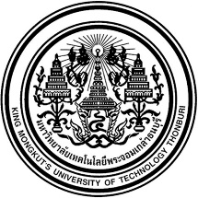
Permission to Publish the Exam
☐ Allowed ☐ Not Allowed
Subject
MTH10202
Vectors, lines and planes
in three-dimensional space
and vector functions
--------------------------
Exam Time
09.00 – 12.00 (3 Hours)
Note (Optional)

* This exam has been reviewed and approved by the Department of Math Committee. *
Permissions 1. Pens, Pencils, and calculators are allowed.
2. Mobile phone and computer are not allowed.
3. No other documents are allowed except by the formula sheet provided.
Instructions 1. This exam consist of three parts – 10 pages (cover included)
2. Part A – 20 Multiple Choice Questions (Worth 50 points). Students are going to submit their answers in the provided answer sheets.
3. Part B – 1 long question (Worth 10 points). Students are going to submit their answers with all rough work.
4. Part C – 1 long question (Worth 10 points). Students are going to submit their answers with all rough work.

Lecturer / Course Coordinator
………………………………………………
Tel : …………………………..

Head of Department
…………………………………………
Name-Surname : ____________________________ Student ID : ______________
Department : _______________________________ Section : _________________
Seat No. ___________
Exam Set (Optional) : 2
Exam Date
25 October 2023
Program
☒ Thai
☐ International

